PRESS RELEASE
Accreditation in accordance with DIN EN ISO/IEC 17065:
DAkkS accredits PlastCert as a certification body for RecyClass Recycling Process and RecyClass Recycled Plastic Traceability
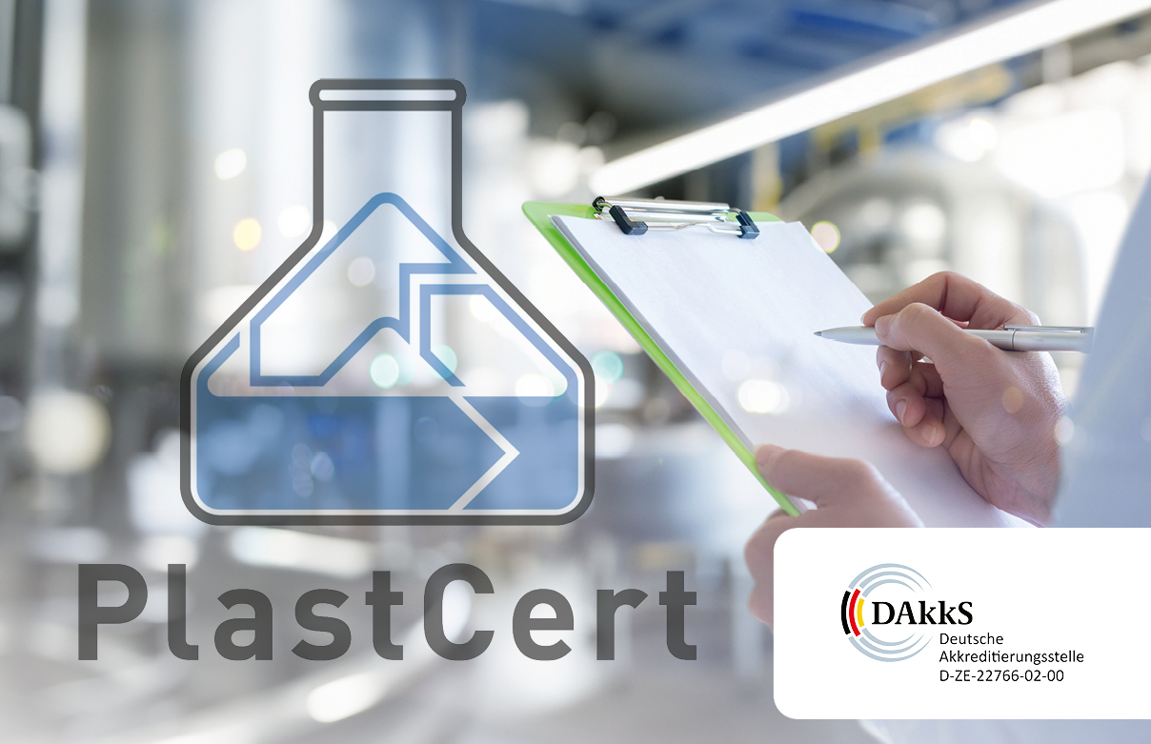
The PlastCert team is delighted with the official recognition by DAkkS as a certification body for the RecyClass Recycling Process and RecyClass Recycled Plastic Traceability certifications.
© RIGK
Wiesbaden, October 2025 – In early August 2025, the German Accreditation Body (DAkkS) officially accredited PlastCert, a division of RIGK GmbH, in accordance with DIN EN ISO/IEC 17065 for the certification programmes “RecyClass Recycling Process” and “RecyClass Recycled Plastic Traceability”. Based on this internationally recognised standard, DAkkS thereby underscores PlastCert’s well-established expertise in the certification of plastic products and recycling processes.
Accreditation by DAkkS ensures that PlastCert, as a certification body, meets the highest standards of competence and impartiality. It promotes ongoing quality assurance and continuous improvement of certification processes. This strengthens confidence in PlastCert’s certifications among both certified companies and purchasers of certified products.
PlastCert has been accredited by DAkkS for the “RecyClass Recycling Process” and “RecyClass Recycled Plastic Traceability” programmes. The RecyClass Recycling Process Certification verifies the traceability and origin of plastic waste within the recycling process. The RecyClass Recycled Plastic Traceability Certification ensures the traceability of recycled content in products across the entire value chain and confirms the proportion of post-consumer and pre-consumer material. These certifications enable companies to transparently demonstrate and communicate the origin and share of recycled materials in their products. Both programmes are fully aligned with the EN 15343:2007 and ISO 22095:2020 standards.
Konstantin Humm, Manager of the PlastCert division at RIGK, commented: “Accreditation by DAkkS is the official recognition of our work as an independent certification body and represents a significant milestone for us. It confirms that our certifications and audits are carried out in line with the highest quality standards, thereby further strengthening our customers’ trust in our services. Ultimately, this now enables us to make an even more effective contribution to the circular economy and to the transparent use of recycled plastics.”
Further more information:
RIGK GmbH  Konstantin Humm (Manager PlastCert)  Friedrichstr. 6  D-65185 Wiesbaden  Phone: +49 (0) 6 11/ 30 86 00-91  humm@rigk.de; www.rigk.de | Editorial Contact, Complimentary Copies:  Konsens PR GmbH & Co. KG  Dr.-Ing. Jörg Wolters  Hans-Böckler-Straße 20  D-63811 Stockstadt  Phone: +49 (0) 60 27/99005-13  mail@konsens.de; www.konsens.de
You can download this press release as a Word document, along with print-quality images, at: https://www.rigk.de/en/worth-knowing

